**DEPARTMENT OF DATA ANALYTICS**

**VEPHLA UNIVERSITY**

**LESSON DAY 16s TASK NUMBER 16B (II)**

**ALO SAVE IBU**

**VEPH/20B/DA097**

**TECHNICAL REPORT FOR KINKSRTON AND SON’S ANALYSIS FOR THE YEAR 2023**

**OUTLINE**

* **Introduction**
* **Story of Data**
* **Data Splitting and Preprocessing**
* **Pre-Analysis**
* **In-Analysis**
* **Post-Analysis and Insights**
* **Data Visualizations & Charts**
* **Recommendations and Observations**
* **Conclusion**
* **References & Appendices**

**INTRODUCTION**

**Objective of the Project**: This project is designed to analyze the general performance of the different category of goods sold by the company the sales and payment channel, regional performance, sales Persons and the type of customer to identify key areas that needs improvements and subsequently make data driven decisions.

**Problem Being Addressed**: This project is trying to identify lapses in any of the following: product category, product category quantity sold, Salespersons, sales and payment channel and type of Customers which if addressed will lead to improvement in revenue generation.

This project is also trying to identify areas with exceptional performance and explore measures to sustain such performance in subsequent months/years.

**Key Datasets and Methodologies**: The dataset used is the order details. The methodology employed is the use of pivot tables, line charts, bar charts, column charts and pie charts to analyze the data to identify trends and hidden patterns.

**STORY OF DATA**

**Data Source**: The data is from the internal company database.

**Data Collection Process**: This data was obtained from Kaggle.com

**Data Structure:** The data contains 1002 rows with each representing a distinct transaction. And 14 columns representing Product ID, Sale date, Sales Rep, Region, Sales amount, Quantity sold, product category, unit cost, unit price, customer type, discount, payment method, sales channel, payment method, sales channel, Region an sales rep.

**Important Features and Their Significance**:

* **Product ID:** this variable identifies and distinguish the different products by their ID numbers.
* **Product category:** this variable will help us to identify and separate the different products based on their category and ultimately analyze how each category is performing.
* **Sale date:** this variable will help us to identify and categorize a sales timeline in order to establish a trend.
* **Region:** this variable will help us to identify and classify the customers into different locations.
* **Sales amount:**  this variable will help us to determine the cost of selling a product and determine the total sales at the end of the business year.
* **Quantity sold:** this variable will help us to determine the quantity of a particular product/ product category sold.
* **Unit coot, Unit price:** these variables will help us analyse the cost of production and price of the products.
* **Customer Type:** this variable will help us to identify and classify the customers.
* **Discount:**  this variable will help to identify and analyse the discounts offered by the company.
* **Payment Method:**  this variable will help to identify and analyse payment methods.
* **Sales Channel:** this variable will help to identify and analyse the sales channel for the business.

**Data Limitations or Biases**

There is no data limitations observed.

**DATA SPLITTING AND PREPROCESSING**

**Data Cleaning:** The data was cleaned by removing duplicates, identifying and removing blanks, and ensuring that no inconsistencies are observed.

To remove duplicate, simply copy the entire data (ctrl +shift + end) then navigate to the data tab and on the data tools ribbon to select “remove duplicates”.

To identify and remove blanks, simply copy the entire data (ctrl +shift + end) on the home tab navigate to the editing ribbon and click “Find and select”, then navigate to “Go to Special” and select “Blanks”, finally click on OK.

**Handling Missing Values**: There was no missing values in the data.

**Data Transformations:** No data transformations were performed.

**Data Splitting:** The data was splitted into dependent and independent variables. The dependent variables are Order ID, Sale date, Sale Amount, Quantity sold, unit cost, Unit price and Discount.

While the independent variables are Sales Rep, Region, Product Category, Customer Type, Payment type, Sales Channel.

**Industry Context**: The data is from sales industry this data will help us understand the dynamics of analyzing sales which will help sharpen our prescriptive and predictive analytical skills.

**Stakeholders:** The chief executives, the head of sales and marketing.

**Value to the Industry**: This analysis will help to identify areas in the business that are lagging for the stakeholders to explore measures for improvements and make appropriate changes / adjustments to bring in more sales.

This analysis will also help to identify areas where the business is doing well for the stakeholders to explore measures to sustain such and maintain/ improve sales.

**PRE-ANALYSIS**

**Key trends:** By merely glancing through the data, it appears as though transfer payment is the preferred payment type.

**Potential Correlations**:.

**IN-ANALYSIS**

**Unconfirmed Insights**:

1. January is the best sales month with a total sales of $495,420.37 while June was the lowest sales month with a total sales of $374,242.88

2. David closed the year as the best sales Rep with a total sales of $1,369,612.51 while Charlie is the least performing sales rep with a total of $860,811.48

3.The best region by total sales is the North with a total sales of $154,250.86 while the least performing region is the South with a total sales of $1,141,737.36

4. returning customers did more purchases than new customers

5. clothing is the highest-selling product category in quantity and income while food is the least sold product category in quantity and income.

6. most customers prepare credit and bank transfer for payments.

7. Retail customers made more purchases than online customers.

**Recommendations**:

1. Find out what happened in June and try to replicate what happened in January

2. Reward David for his outstanding performance and place Charlie on performance improvement plan

3. Reward sales reps from the North and ensure the momentum is sustained in the coming year

4. Ensure the sales reps are working hard to bring in new customers to sustain the business

5. Ensure there is no stock out of clothing and ensure other least performing products are given attention in the coming year.

6. ensure smooth and effective payment devices are used

7. create more online awareness to bring in more online customers and encourage more online purchase

**Analysis Techniques Used in Excel**:

Pivot Tables were used to analyze the data in order to generate meaningful visual insights.

Other features used are

Grouping- this was used to group the dates from days to Months

Sorting- this was used to arrange data from the highest to the lowest and vice versa.

**POST-ANALYSIS AND INSIGHTS**

**Key Findings**:

1. David closed the year as the best Sale Rep with a total sales of $1,369,612.51. His best sales are in October. His major customers are new customers.

His major product category by sales is clothing while furniture is his major product category by quantity sold. cash and credit are his major payment channel.

1. Charlie closed as the least performing sales Rep with a total of $860,811.48. the best Sales month is January and June. The customers are mostly returning customers. clothing is the major product category sold. Most customers are online.
2. The best region by total sales is the North with a total sale of $154,250.86 while the least performing Region is the south with a total sale of $1,141,737.36.
3. The best products in the regions are;

East - Clothing

South- Furniture

West- Food

North - Furniture

1. The major customers in the East and North are new customers while the West and South are returning customers.
2. The East and South usually transact on credit and cash while the North and West usually transact with bank transfer.

**Comparison with Initial Findings**:

We initially expected Bank transfer to be the most preferred payment method in all regions but on analysis we discovered that Bank transfer is mostly preferred in the North and West while the East and South prefers Credit and Cash payments.

**DATA VISUALIZATIONS & CHARTS**

**SALES TREND FOR THE YEAR**

The above sales trend chart highlights the monthly sales performance of the company from January to December.

January is the best sales month at $ 495,420.37 while least sales month is September at $367,837.60.

**PRODUCT CATEGORY**

The above chart highlights the sales of different product categories. Clothing is the leading category at $1,313,474.36 closely followed by furniture at $1,260,517.69. Electronics and food occupied the bottom of the sales by product category closing at $1,243,499.64 and $1,201,773.54 respectively.

**PRODUCYT CATEGORY QUANTITY**

This chart highlights the quantities of each product category sold for the year. Clothing is leading at 6,922 units sold closely followed by furniture at 6,729 units sold and then electronics at 6,096 units sold then lastly, at the bottom is food at 5,608 units sold.

**SALES CHANNEL**

The above chart highlights the channel for the sales achieved for the year. Retail sales closed at $2,560,432.30 while Online sales trailed behind at $2,458,833.93 for the year.

**PAYMENT CHANELL**

The above chart highlights the payment channel for all payments received for the year. Credit card payments is leading at $1,757,563.52 closely followed by bank transfer at $1,717,363.17 and lastly cash payment occupying the bottom of the payment channel at $ 1,544,338.54.

**REGIONAL SALES**

The above chart highlights the regional sales performance. The north is leading the pack at $1,369,612.51 closely followed by the east at $1,259,792.93 while the west is trailing at $1,235,608.93 and lastly at the bottom is the south with a total sales of $ 1,154,250.86.

**CUSTOMER TYPE**

The above chart highlights the customer type for the business done in the year. Leading the pack is returning customers accounting for $ 2,513,006.93 of the total sales while new customers trailed behind at $2,506,258.30 of the total sales for the year.

**SALES REP PERFORMANCE**

The above chart highlights the individual sales performance of the sales reps. David is leading the pack at $1,141,737.36 followed by Bod at $1,080,990.63 while Eve and Allice came close to each other at $970,183x,99 and $965,541.77 respectively and at the bottom of the saales ranking is Charlie closing at $860,811.48 for the year.

**FINAL DASHBOARD**

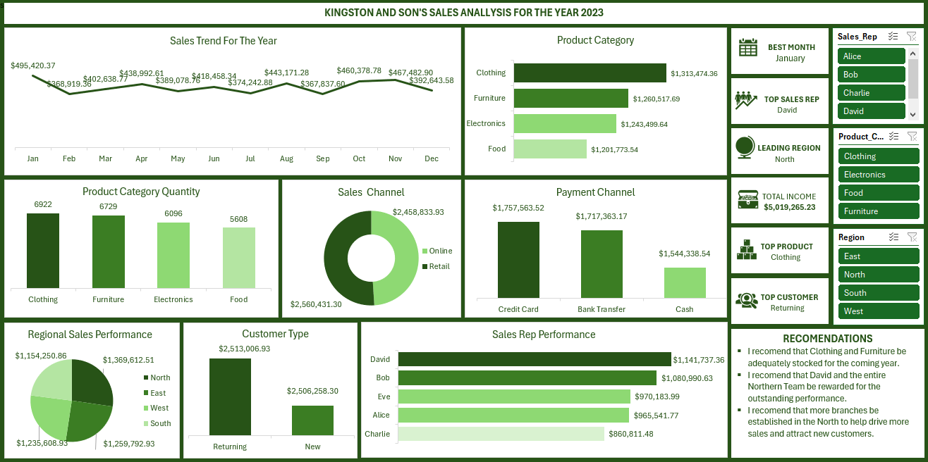

The final dashboard highlights the combined correlations and relationship between the individual charts with the help of slicers.

**RECOMMENDATIONS AND OBSERVATIONS**

**Actionable Insights**

1. Find out what happened in June and try to replicate what happened in January

2. Reward David for his outstanding performance and place Charlie on performance improvement plan

3. Reward sales reps from the North and ensure the momentum is sustained in the coming year

4. Ensure the sales reps are working hard to bring in new customers to sustain the business

5. Ensure there is no stock out of clothing and furniture and also ensure other least performing products are given attention in the coming year.

6. ensure smooth and effective payment devices are used in the coming year to encourage more online business.

7. create more online awareness to bring in more online customers and encourage more online purchase.

8. efforts should be put in place to bring in more new customers to ensure the business continues to grow in the coming year.

**Optimizations or Business Decisions:**

More New customers should be introduced as this will help generate more business and sales in the coming year.

Promotional activities should be conducted during periods with poor sales.

More discounts should be introduced for least selling products to enhance purchase

Periodic trainings should be performed for the salespersons to ensure improvement.

**Unexpected Outcomes**:

None.

**CONCLUSION**

**Key Learnings**:

1. David closed the year as the best Sale Rep with a total sales of $1,369,612.51. His best sales are in October. His major customers are new customers. His major product category by sales is clothing while furniture is his major product category by quantity sold. cash and credit are his major payment channel.
2. Charlie closed as the least performing sales Rep with a total of $860,811.48. the best Sales month is January and June. The customers are mostly returning customers. clothing is the major product category sold. Most customers are online.
3. The best region by total sales is the North with a total sale of $154,250.86 while the least performing Region is the south with a total sale of $1,141,737.36.
4. The best products in the regions are;

East - Clothing

South- Furniture

West- Food

North - Furniture

1. The major customers in the East and North are new customers while the West and South are mostly returning customers.
2. The East and South majorly transact on credit and cash while the North and West majorly transact with bank transfer.

**Limitations**:

The data does not put into account external factors such as competitor activities, seasonal trends, market dynamics and internal factors such as product availability, logistics delays, price increments and understaffing, etc. that may affect sales during the year.

**Future Research**

Additional research can be conducted on the implications of discount (positive or negative) on sales.

**REFERENCEE:** The data or this project was obtained from Kaggle.com